Alberto Watches
Developer Guide
Supervisor. Maira Syed
Batch. 2605E1
Group. E-Project - (B) Group
Serial No. | Student ID Number | Student Name
1. | 1729384 | Abdullah
2. | 1731677 | Fasih
3. | 1612252 | Zohair
4. | 1730589 | Mudassir

ACKNOWLEDGEMENT
First, we would like to express our special thanks of gratitude to our teacher Maira Syed, who helped us a lot in finalizing this project within the limited time frame, and for her valuable counselling and assistance in the accomplishment of this project.
Secondly, we would also like to thank the eProject team at Aptech Head Office, who gave us the golden opportunity to do this wonderful project about Alberto Watches.
Thirdly, we also thank the eProject team. Some of the benefits are as under:
- Re-enforcement of skills happens in the experiential learning process.
- A mentor, ensuring that we do not get drifted, constantly guides us.
- It gives us a lot of confidence to face an interview as we have worked on a project. We can explain virtually everything on the subject we have learnt.

Synopsis
Alberto Watches: Time, Perfected.
As digital technology and online shopping evolve, a watch has become more than a time-telling device — it is a statement of character. Every buyer needs a refined, trustworthy place to explore, compare and order timepieces that match their style and budget. Alberto Watches is a modern luxury-watch destination built for exactly that purpose, serving customers across Pakistan.

Our Curated Collections
The catalogue of Alberto Watches contains 36 handpicked timepieces from leading watchmakers such as Seiko, Citizen, Tissot, Rado, Casio and Movado, along with Royal London. The collection is organised into three categories — Men's Watches, Women's Watches and Luxury Edition — so that every customer can quickly reach the watch that suits their taste, from everyday classics to premium collector pieces.

The Gift of a Watch
A watch is one of the most meaningful gifts. Whether you are looking for a present for a loved one, a milestone reward for yourself, or an elegant accessory for a special occasion, the platform guides you to the right timepiece with clear images, brand names, badges and prices.

Explore & Order
Alberto Watches works as a showcase and order-request platform. Customers browse the collection, add watches to a shopping bag or press Buy Now, and then fill in the order form. On confirmation, the order details are prepared as a ready-made WhatsApp message to the business, and the Alberto Watches team contacts the customer to confirm the order. Payment is handled after confirmation through Cash on Delivery, Easypaisa, JazzCash or Bank Transfer; no card payment is taken directly on the site.

PROBLEM DEFINITION

The Digital Evolution of Alberto Watches
Watches have traditionally been sold through physical shops, where customers are limited to the stock of one location and the opening hours of the store. In an era of instant connectivity and online shopping, modern customers expect to explore a complete catalogue, compare prices and place an order from their phone or computer at any time.
To address this, Alberto Watches has been developed as a responsive, single-page online storefront. To ensure a world-class experience, the platform focuses on the following core objectives:
1. High-Efficiency Sitemap
The navigation structure is simple and intuitive. A sticky header with Home, Collections, Watches, Brands, About and Contact links gives instant access to every section of the page, while the category filters (All, Men's, Women's, Luxury) and the live search let users reach a specific watch or brand with a single click.
2. Comprehensive Content Display
Each section is visually immersive. Beyond the watch name, every product card displays a high-quality image, the brand, a status badge (such as New, Bestseller or Luxury), a star rating and the price in Pakistani rupees. Quick View shows a larger preview of the selected watch.
3. A Positive Customer Culture
To build trust, the site includes a trust bar (Fast Delivery, 100% Authentic, Premium Support, Secure Payment), customer reviews, promotional offers and a newsletter sign-up, creating a friendly and reliable shopping environment.
4. Optimized User Experience (UX)
The interface is built for seamless flow. The shopping bag drawer, Quick View window, search overlay and notification toast open on the same page without reloading, and the cart count in the header is always visible. Every element is positioned to reduce friction and make ordering easy.
5. Seamless System Performance
The website is lightweight and responsive. Product images are lazy-loaded, products are rendered instantly by JavaScript from a single data array, and the shopping bag is saved in the browser (localStorage) so it is not lost when the page is refreshed. The layout adapts to desktop, tablet and mobile screens.
6. Direct Expert Advice
Customers are not just buyers; they are part of the Alberto family. Through the contact section, phone number, e-mail address and WhatsApp support, customers can ask for advice, confirm availability, or get help choosing the perfect watch.

CUSTOMER REQUIREMENT SPECIFICATION (CRS)
A menu should be created which categorizes all the information about the features provided on the site, e.g. a menu for the various categories of watches, a menu for the brands, a menu for the current offers, etc.
The categories of watches are:
1. All Watches
2. Men's Watches
3. Women's Watches
4. Luxury Edition
The featured brands are Seiko, Citizen, Tissot, Rado, Casio and Movado (Royal London is also available in the women's range).
On selecting any category, the site displays the related watches with the following information:
- Watch details: brand, model name, image and status badge
- Price in Pakistani rupees (Rs.) and star rating
- Quick View: a larger preview of the selected watch
- Actions: Add To Cart, Buy Now and Wishlist
The site should also display:
- Promotional offers: 10% off the first order (code ALBERTO10), 15% off Men's, 20% off Women's and 25% off Luxury Edition in a sale slider
- The featured brands section and the luxury editorial banner
- Customer reviews under the "What Our Customers Say" section
- An About section describing the vision of Alberto Watches
Users should be able to perform searches by:
1. Watch name
2. Brand name
Users and ordering:
All visitors can browse the entire catalogue and place an order as guests; no registration is required. A shopping bag is kept on the visitor's device. To place an order the customer provides name, phone, e-mail, city, delivery address and a payment method (Cash on Delivery, Easypaisa, JazzCash or Bank Transfer). The order is then sent to the business as a WhatsApp message for confirmation. The Account button in the header is reserved for a future registered-user feature.

Hardware / Software Requirements
Hardware
- Any computer, laptop, tablet or smartphone capable of running a modern web browser
- Minimum recommended: dual-core processor and 2 GB of RAM
- An active internet connection (required for Google Fonts, Font Awesome icons and product images)
Software
- Operating system: Windows, macOS, Linux, Android or iOS
- Browser: latest version of Google Chrome, Microsoft Edge, Mozilla Firefox or Safari
- WhatsApp (mobile or web) to send the prepared order message
- Development tools: Visual Studio Code (or any code editor), HTML5, CSS3, JavaScript (ES6)

SCOPE OF THE WORK (IN BRIEF)

Scope of Work (SOW): Alberto Watches Platform
1. Core Platform Development
- Web-Based Watch Store: Develop a responsive e-commerce style storefront using HTML5, CSS3 and vanilla JavaScript (no framework).
- Responsive User Interface: Build a luxury theme (gold #A67C43, black and warm off-white) using the Playfair Display and Inter typefaces that remains fully functional on desktop and mobile browsers.
- Persistent Shopping Bag: Implement a slide-in cart drawer whose contents are saved in localStorage and survive page refreshes.
2. Feature & Module Implementation
- Dynamic Product Display: Generate product cards from the watches array in JavaScript, with category filters for All, Men's, Women's and Luxury.
- Navigation: Sticky header with section links, mobile hamburger menu, search, account and shopping-bag buttons.
- Order System: Order form with live total calculation and payment-method information, which prepares a WhatsApp order message.
- Search Functionality: A search overlay with real-time results by watch name or brand.
3. Content & Metadata Management
- Watch Catalogue: 36 watches, each with an ID, brand, name, price, category, badge and image path.
- Marketing Content: Hero banner, sale slider, trust bar, brands, collections, editorial banner, about, offer, reviews and newsletter sections.
4. Technical Performance
- Image Optimization: Lazy loading of product images for faster page load.
- Cross-Browser Compatibility: Testing to ensure the platform functions properly on Chrome, Edge, Firefox and Safari.
- Responsive Design: CSS media queries at 900px and 600px to adapt the layout for tablets and phones.

AGGREGATED SITEMAP
1. Header & Global Navigation
- Announcement Bar: Free shipping across Pakistan, 10% off first order, 100% authentic watches, secure checkout.
- Main Navigation: Home, Collections, Watches, Brands, About, Contact.
- Header Actions: Search (live search overlay), Account (reserved) and Shopping Bag with item counter.
2. Home Page Architecture (Main Grid)
- Hero Section: "Time, Perfected." banner with Explore Collection and Order Now buttons.
- Sale Slider: 10%, 15%, 20% and 25% offers.
- Trust Bar: Fast Delivery, 100% Authentic, Premium Support, Secure Payment.
- Featured Brands: Seiko, Citizen, Tissot, Rado, Casio, Movado.
3. Collections & Watches
- Collections: All Watches, Men's Watches, Women's Watches, Luxury Edition.
- Our Finest Watches: Filter buttons and the product grid (36 watches).
- Product Card: Badge, image, brand, name, rating, price, Wishlist, Quick View, Add To Cart, Buy Now.
4. Brand Story & Social Proof
- Editorial Banner: "A watch is more than an accessory."
- About Section: Our Story — Time With Character.
- Limited Time Offer: Get 10% off your first order.
- Customer Reviews: Three five-star customer stories.
5. Order & Contact
- Contact Information: Karachi, Pakistan; phone; e-mail.
- Order Form: Name, phone, e-mail, watch, quantity, city, payment method, delivery address and total; Confirm Order opens WhatsApp.
6. Overlays (Functional Pop-ups)
- Search Overlay, Shopping Bag Drawer, Quick View Modal and Toast Notification.
7. Newsletter & Footer
- Newsletter: Join The Inner Circle sign-up.
- Footer Columns: Brand & social links; Shop; Information (About, Contact, Shipping & Delivery, Returns & Exchange, Privacy Policy); Contact (address, phone, e-mail, WhatsApp).

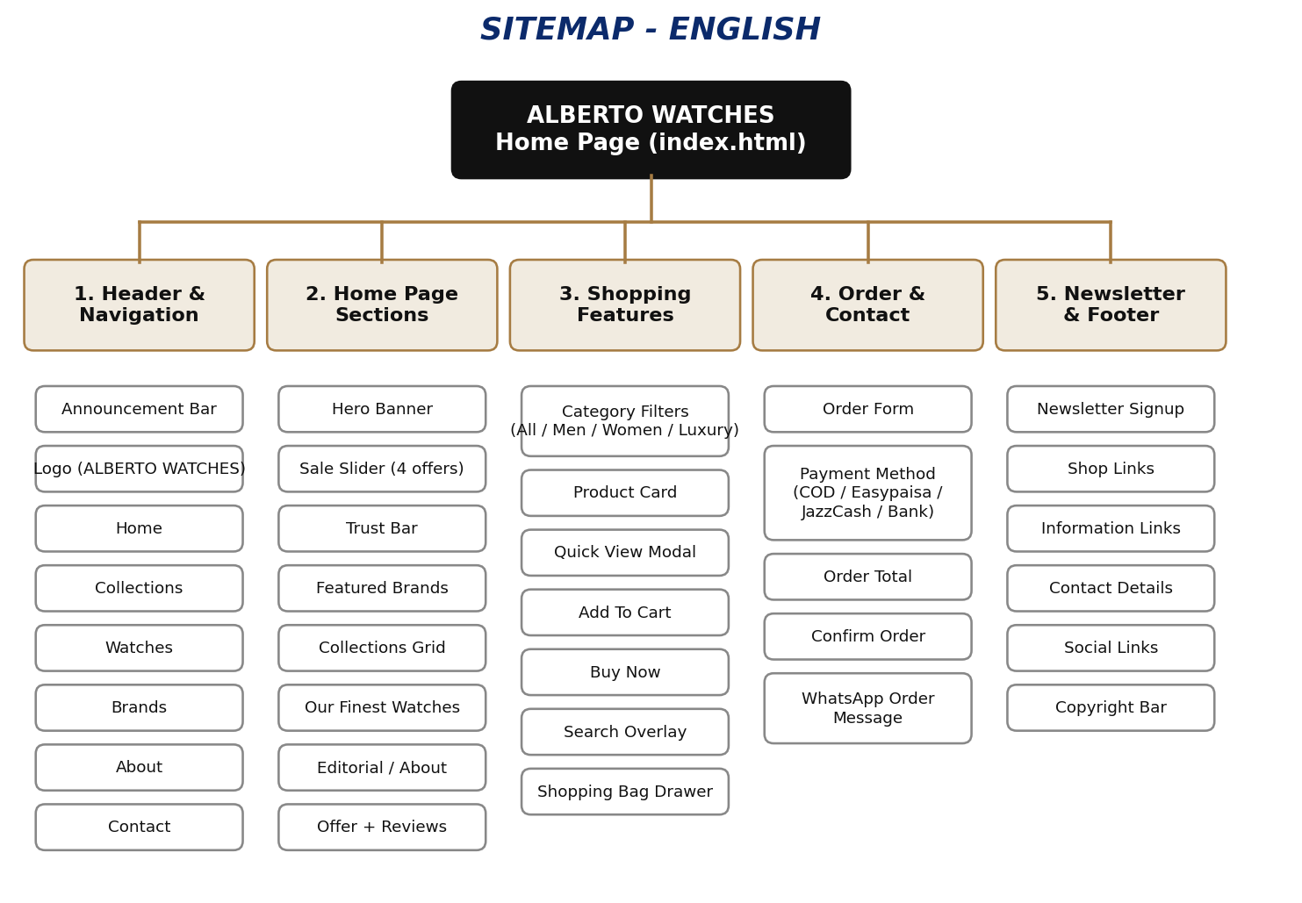

WIREFRAMES
1. Main Layout (Header, Hero, Sale Slider, Trust Bar, Brands)
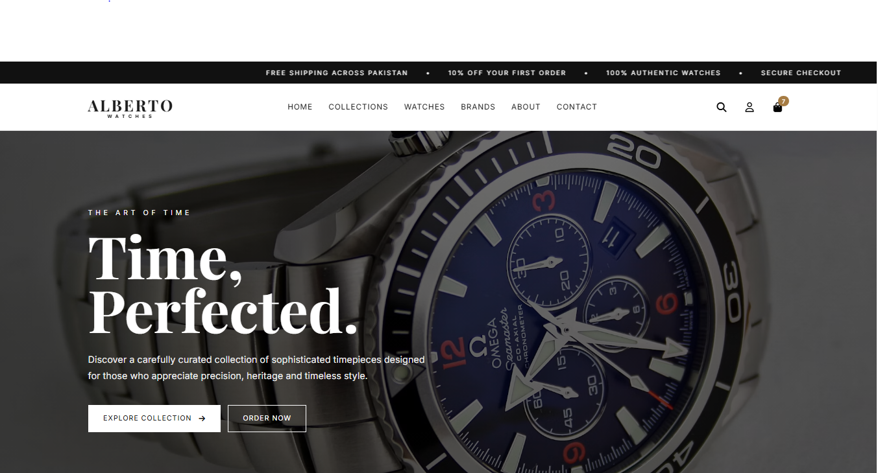
2. Collections & Watches Section
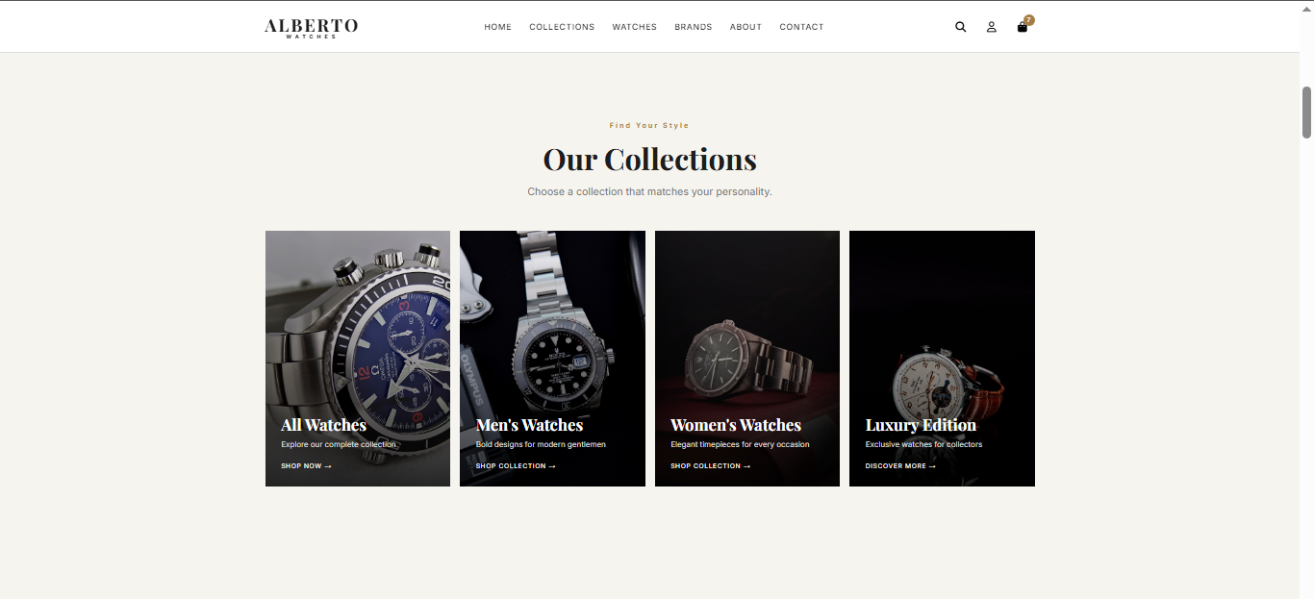

3. Product Card & Quick View
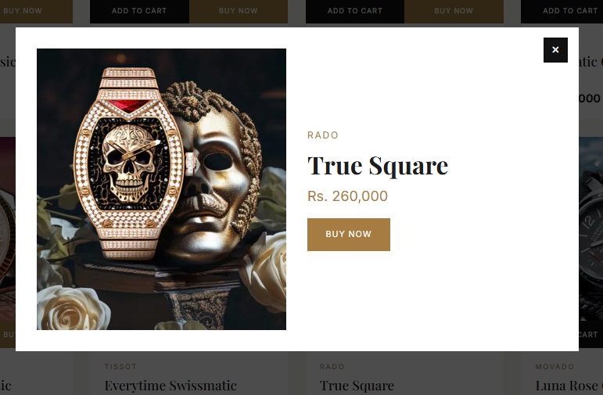
4. Search Overlay & Shopping Bag
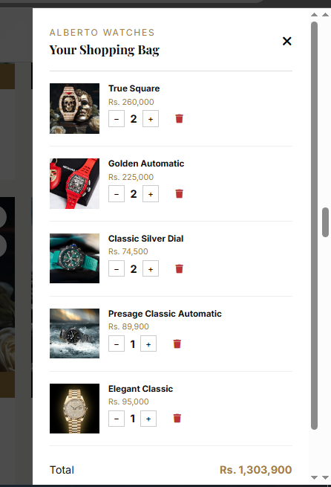

5. Order Form (Contact Section)
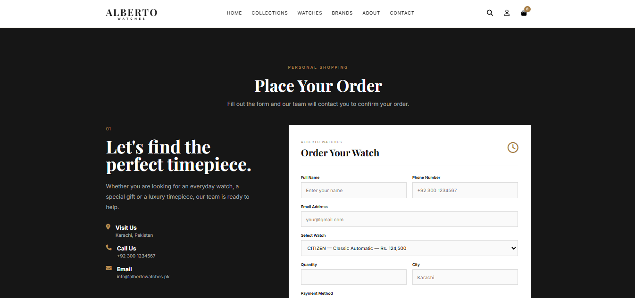
6. Newsletter & Footer
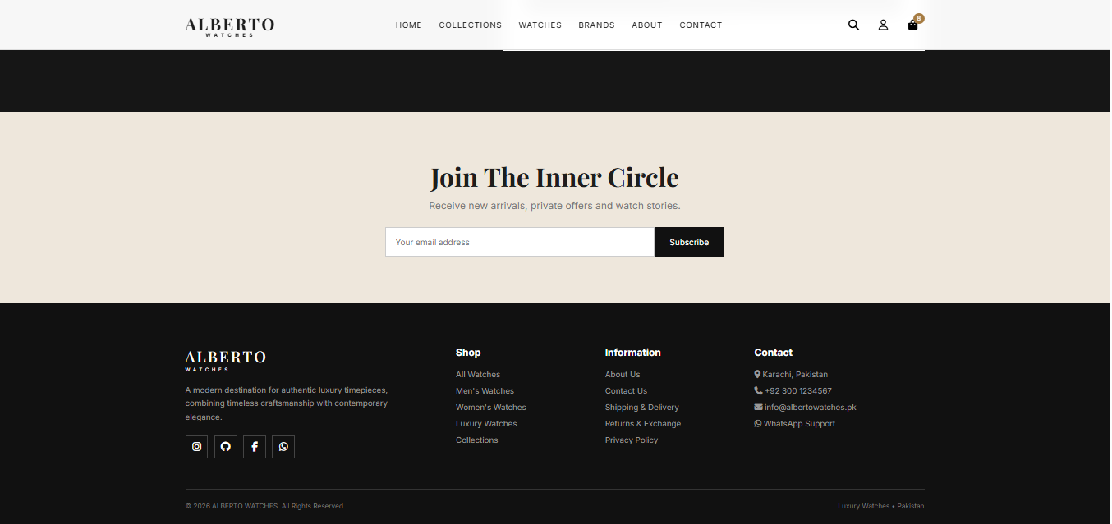

TECHNICAL DOCUMENTATION

1. Technology Stack
Technology | Purpose
HTML5 | Page structure — all sections in a single index.html
CSS3 | Styling and responsive layout in style.css (flexbox, grid, media queries)
JavaScript (ES6) | All dynamic behaviour in script.js — no framework or library
Google Fonts | Playfair Display (headings) and Inter (body text)
Font Awesome 6.5.2 | Icons, loaded from cdnjs
localStorage | Saves the shopping bag under the key "albertoCart"
WhatsApp (wa.me) | Receives the prepared order message

2. Project File Structure
File / Folder | Description
index.html | Markup of the whole website (header, sections, overlays, footer)
style.css | All styles, colour theme, animations and responsive rules
script.js | Watch data and all functionality (the code supplied as javascript_coding.txt)
images2.0/ | Folder of watch images referenced by each watch in the data array

3. Design System
- Primary accent: Gold / bronze #A67C43 (hover shade #8E6634) for buttons, badges, prices and highlights.
- Base colours: Warm off-white background #F6F4EF, near-black #111 for the header, footer and primary buttons, text #1D1D1D.
- Typography: Playfair Display (serif) for headings and prices; Inter (sans-serif) for body text and buttons.
- Layout: A centred .container (maximum width 1200px, 92% on small screens) with grid layouts for brands, categories, products and reviews.
- Breakpoints: max-width 900px (tablet: mobile menu appears, grids collapse) and max-width 600px (phone: single-column layout).

4. Watch Data Structure
All 36 watches are stored in the watches array at the top of script.js. Every object has the following fields:
Field | Type | Description
id | Number | Unique identifier (1–36), used by the cart, Quick View and order form
brand | String | Brand name, e.g. "SEIKO"
name | String | Model name, e.g. "Presage Classic Automatic"
price | Number | Price in rupees, e.g. 89900 (formatted as Rs. 89,900)
category | String | men, women or luxury (used by the filter buttons)
badge | String | Label on the card, e.g. New, Bestseller, Premium
image | String | Path of the watch image inside images2.0/
Catalogue summary: 36 watches — 15 Men's, 9 Women's and 12 Luxury; Seiko, Citizen, Tissot, Rado and Movado have 6 watches each, Casio has 5 and Royal London has 1; prices range from Rs. 18,500 to Rs. 285,000.
How to add a new watch
Copy an existing object in the watches array, give it the next unused id, fill in brand, name, price, category (men / women / luxury), badge and image, and save the image in the images folder. The product grid, search, order-form dropdown, cart and Quick View all use this array, so nothing else needs to be changed.

5. JavaScript Functions Reference
Function | Purpose
formatPrice(price) | Converts a number to a rupee string such as "Rs. 89,900".
saveCart() | Writes the cart array to localStorage.
displayProducts(filter) | Builds the product cards for the chosen category (default "all") and adds them to #products.
attachProductButtons() | Attaches click events to Add To Cart, Buy Now and Quick View buttons.
addToCart(id) | Adds a watch to the cart or increases its quantity, then updates the bag and shows a toast.
updateCart() | Redraws the cart drawer, the header counter and the cart total.
changeQuantity(id, amount) | Increases or decreases quantity; removes the item when it reaches zero.
removeFromCart(id) | Deletes an item from the cart.
buyNow(id) | Pre-selects the watch in the order form, scrolls to the Contact section and focuses the name field.
loadOrderWatches() | Fills the Select Watch dropdown from the watches array.
calculateOrderTotal() | Calculates price × quantity and shows it as the Order Total.
showQuickView(id) / closeQuickView() | Opens or closes the Quick View modal for a watch.
closeSearch() | Closes the search overlay.

6. Event Handlers
- Payment Method (change): shows the matching payment instruction (Cash on Delivery, Easypaisa, JazzCash or Bank Transfer).
- Select Watch (change) and Quantity (input): recalculate the Order Total.
- Order Form (submit): validates the selected watch, builds the order message and opens WhatsApp using wa.me and encodeURIComponent.
- Cart button / Close / overlay click: open and close the shopping bag drawer.
- Checkout button: copies the first cart item into the order form and scrolls to the Contact section.
- Search input: filters watches by name or brand in real time.
- Filter buttons and Collection cards: show the selected category.
- Mobile menu button: toggles the navigation menu on small screens.

7. Order Flow
Step 1: The customer browses the collection and presses Add To Cart or Buy Now.
Step 2: The selected watch and quantity appear in the Order Form, with the total calculated automatically.
Step 3: The customer fills in name, phone, e-mail, city, payment method and delivery address.
Step 4: On Confirm Order, a formatted message (customer details, address, watch, quantity, price, total, payment method) is created.
Step 5: WhatsApp opens in a new tab with the message ready to send; the Alberto Watches team confirms the order with the customer.

8. Developer Notes & Future Enhancements
The following points were noted while preparing this guide and should be addressed before final deployment:
Item | Note
BUSINESS_WHATSAPP | The order handler uses this constant, but it is not declared in the supplied script. Declare it, for example const BUSINESS_WHATSAPP = "923001234567";, otherwise Confirm Order will fail.
showToast(message) | Called in several places, but its definition is not in the supplied script; it must control the #toast element.
Sale slider buttons | The previous/next buttons (#prevSale, #nextSale) have no JavaScript yet.
Newsletter form | #newsletterForm has no submit handler yet.
Account & Wishlist buttons | These are interface placeholders; registration/login and a wishlist can be added in a future version.
Checkout | The Proceed To Checkout button currently transfers only the first item in the bag to the order form.
Image paths | Most paths begin with a slash (/images2.0/...) while the last three do not; use one consistent relative path so images load on every host.

TASK SHEET REVIEW 2
Project Ref. No.:  eP/Advertisement Portal  Management System/01 |  | Project title | Date of Preparation of Activity Plan
No | Task | Alberto  Watches | Actual  Start Date | Actual  Days | Team-mate  Names | Status
1 | Build Home Page (Hero, Sale Slider, Trust Bar, Brands) | Alberto  Watches | DD/MM/YY | 10 | Fasih | Complete
2 | Build Collections and Watches Section (Product Grid and Filters) | Alberto  Watches | DD/MM/YY | 2 | Zohair | Complete
3 | Build Logo and Header | Alberto  Watches | DD/MM/YY | 1 | Muddasir | Complete
4 | Build Theme (CSS) and Add Watch Images | Alberto  Watches | DD/MM/YY | 7 | Abdullah | Complete
5 | Begin JavaScript for the Home Page (Product Display, Filters, Search) | Alberto  Watches | DD/MM/YY | 1 | Abdullah & Fasih | Complete
6 | Begin JavaScript for Cart, Quick View and Order Form | Alberto  Watches | DD/MM/YY | 1 | Abdullah | Complete
7 | Creative Work (Banners, Images, Offers) | Alberto  Watches | DD/MM/YY | 30 | Mudassir | Complete
8 | Begin Code Support For Browsers | Alberto  Watches | DD/MM/YY | 3 | Zohair | Complete
9 | Check Progress And Assign New Tasks | Alberto  Watches | DD/MM/YY | 30 | All Team | Complete

TASK SHEET REVIEW 3
Project Ref. No.:  eP/Advertisement Portal  Management System/01 |  | Project title | Date of Preparation of Activity Plan
No | Task | Alberto  Watches | Actual  Start Date | Actual  Days | Team-mate  Names | Status
1 | Check color, format, size, JavaScript and responsive layout in the Home page | Alberto  Watches | DD/MM/YY | 2 | Neha & Sufyan | Complete
2 | Check color, format, size, JavaScript and responsive layout in the Collections and Watches section | Alberto  Watches | DD/MM/YY | 2 | Neha & Sufyan | Complete
3 | Check color, format, size, JavaScript and responsive layout in the Cart, Order Form, About and Footer | Alberto  Watches | DD/MM/YY | 2 | Mibsam | Complete
4 | Write a developer guide | Alberto  Watches | DD/MM/YY | 2 | Neha, Sudais, Mibsam, Sufyan | Complete
5 | Write user manuals | Alberto  Watches
6 | Overall inspection of the project | Alberto  Watches | DD/MM/YY | 2 | All Team | Complete

